Unity Newsletter

July 2022

With the summer sun finally making an appearance, the students at Unity have been busy taking part in a variety of outdoor learning activities. As we are nearing the end of the school year, this means that the summer fun can begin with sports’ day, fishing and a lot more!

Beautiful Butterflies

Most recently, our butterflies have finally hatched from their cocoons, enabling our younger students to investigate their life cycle - from a caterpillar, all the way to fully fledged butterflies! The students created posters and pictures to show what they have learned as part of our habitats and life-cycle project. The most exciting part by far, however, was most definitely releasing the butterflies into the wild in the hopes that they will continue to grow and explore the world.

Gone Fishing

As for our older students, summer has presented them with the opportunity for many more outdoor activities. One of which has been fishing! The calm, quiet and rural environment has huge health and well-being benefits for many students, so several times a week we have headed down to a local stream or pond and returned with a whole variety of finds. Fish have always been returned to the river, but more exciting treasure has been hoarded back at Unity!

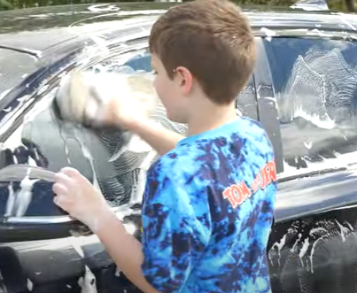At The Carwash!

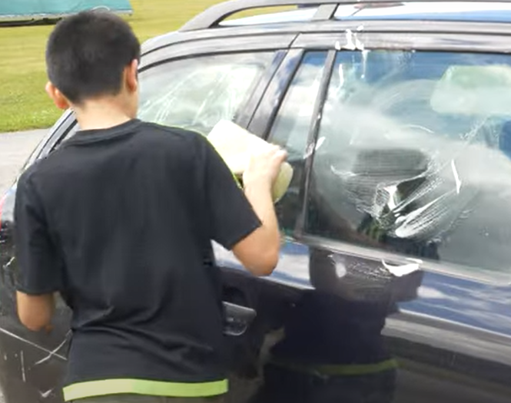Our students have also been learning about first aid treatment recently; specifically regarding CPR and how this can save lives. Because of this, Unity began a collective effort with Sheffield Wednesday to raise enough money to buy a defibrillator for our local community. In order to raise the money, everyone got involved in a charity carwash, and thanks to support from the public and a large, generous donation from The Cleeves and Whitehead Trust, we have now successfully raised enough money to buy our very own defibrillator! More information will follow regarding this once the defibrillator is in place.

On Your Marks!

One of the final activities we’ve taken part in leading up to summer, is to celebrate the end of the school year with Sports’ Day. Completing agility courses, races and athletics, our students had a terrific time getting fit and succeeding in all activities, with an abundance of 1st place medals being awarded. We all give a special thank you to Aaron from Sheffield Wednesday for making sports day possible for us all – everyone had a brilliant time!

And Finally …

With the school year coming to an end, we sadly have to wish a fond goodbye to the students who will be moving on to new schools or post 16 education in September. We wish you lots of success and happiness in the future, and would love for you to pop back and visit sometime.

We also warmly welcome others who will be joining Unity soon, and we really look forward to meeting you all! Regardless of whether you are joining us, leaving us, or simply staying with us as before, we wish you a fantastic time moving forward and hope you have a safe, happy and a totally excellent summer!