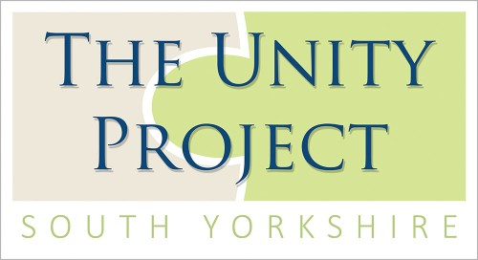**The Unity Project Newsletter**

December 2022

Following on from the summer holidays, we were pleased to welcome our students back and meet all of our newcomers. It’s taken us no time at all to get back into the swing of things here at Unity and now we’re on the run up to Christmas, we hope everyone has enjoyed the school term so far.

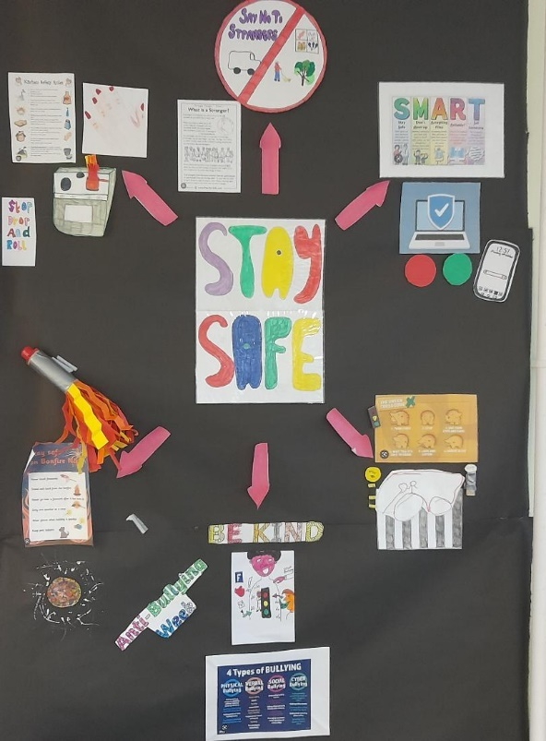Staying Safe

We had incredible fun preparing for Bonfire night. We didn’t forget to learn about the hazards of fireworks, however, as firework safety is something that is very important to us here at Unity. Ensuring we all know how to stay safe on Bonfire night is something we worked very hard on.

Moving on from Bonfire night, our students also learned how to stay safe in a lot of other areas too. From on-line safety and stranger danger, to ant-bullying, road safety and being safe in the kitchen; we know it all!

Lest we Forget

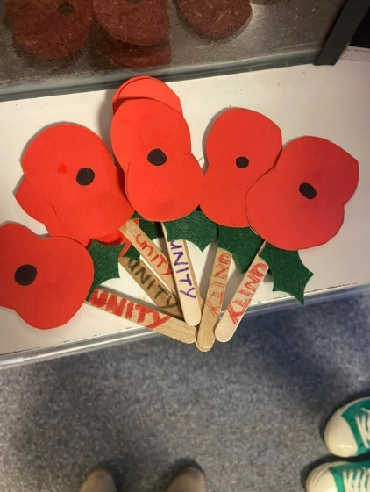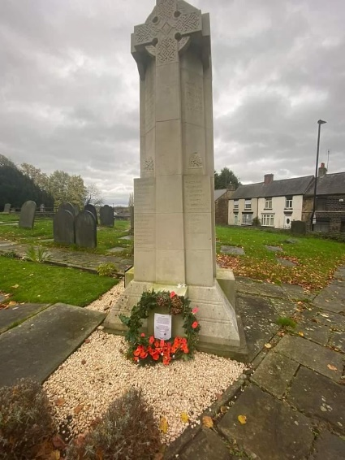We have learned more about the meaning of remembrance in the run up to Armistice Day. Our students studied the events of the World Wars and more recent conflicts, and we learned how important it is to never forget those who fought for us. To commemorate the day, our students made their very own poppies and visited the cenotaph at Ecclesfield Church to pay their respects. One of our younger pupils also read out a poem from WW1. We thank you all for your service!

Three Lions!

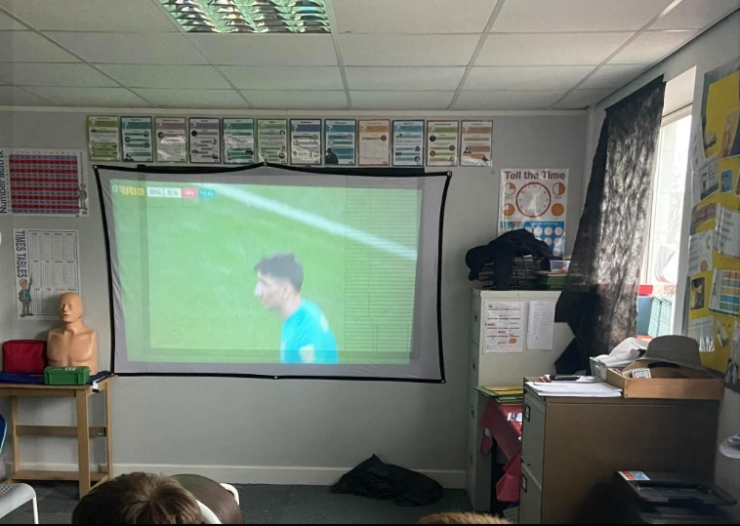Now that the world cup is in its final stages, our students really thought it was coming home! Despite the disappointment, it has been truly fascinating to learn about the sport and how so many countries have come together for this event. Not only has this inspired a great deal of sporting activities, but we’ve also taken the opportunity to learn a whole lot more about the social issues surrounding Qatar. We’ve been looking into the politics and human rights issues related to the World Cup and have had some extremely interesting debates about Qatar being the host country of the World Cup.

It’s Christmas!

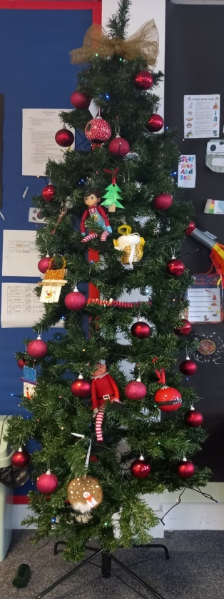In addition to all of this, the students at Unity have been getting in the Christmas spirit! During the run up to the holidays, we’ve been getting ready by making our classrooms look a lot more festive. (With a bit of a rivalry going on as to which floor has the best decorations!) We think both look fantastic!

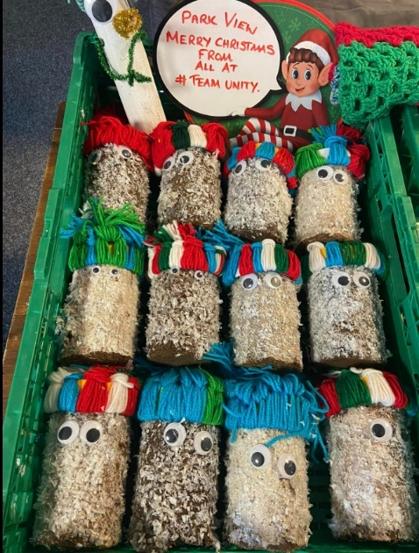In the true spirit of Christmas, we’ve also been doing a lot of giving and maybe even a bit of receiving. All of our students have been writing cards to give to the residents of Parkview Care home. As well as this, we have been gifting some lovely homemade blankets, which we hope will keep everyone nice and cosy in the winter months. We wish all the staff and residents a very Merry Christmas and a Happy New Year!

Christmas is now approaching fast and as we conclude our first term, we look forward to the new year. We hope that all our students and their families have a wonderful break, and we know Father Christmas will be visiting each and everyone of you! From the staff and students at Unity, we wish you a Merry Christmas and a Happy New Year.